**6. Use of DynamoDB**

**Architecture**

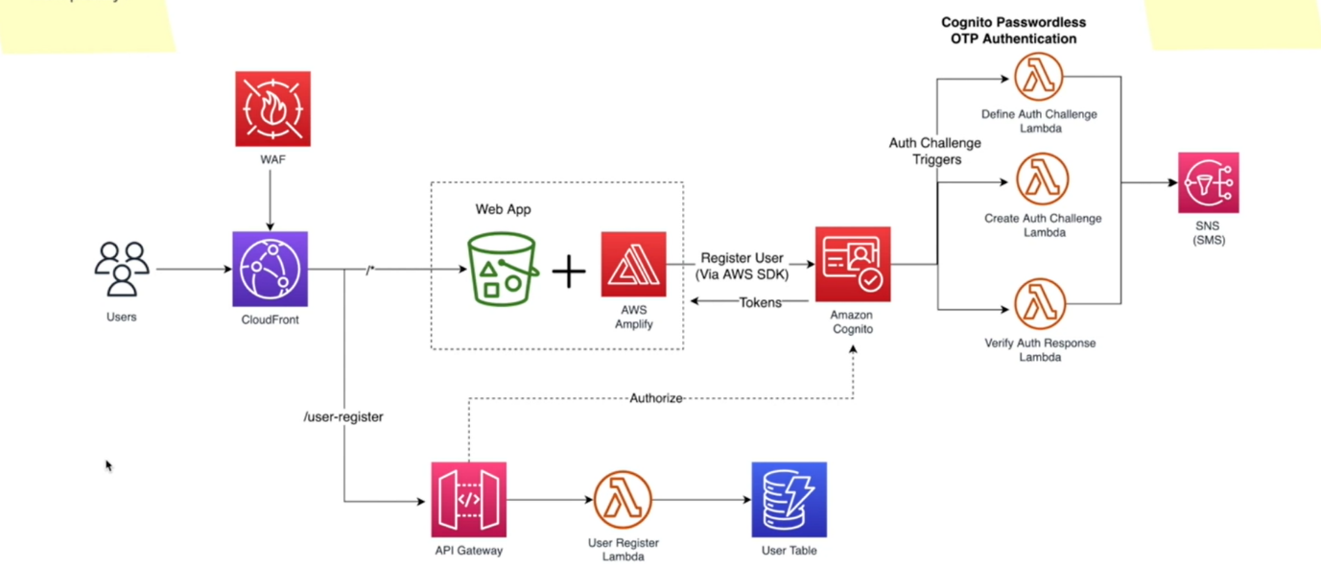

--- when user auth challenge is successful, he has successfully verified his token or OTP rather.

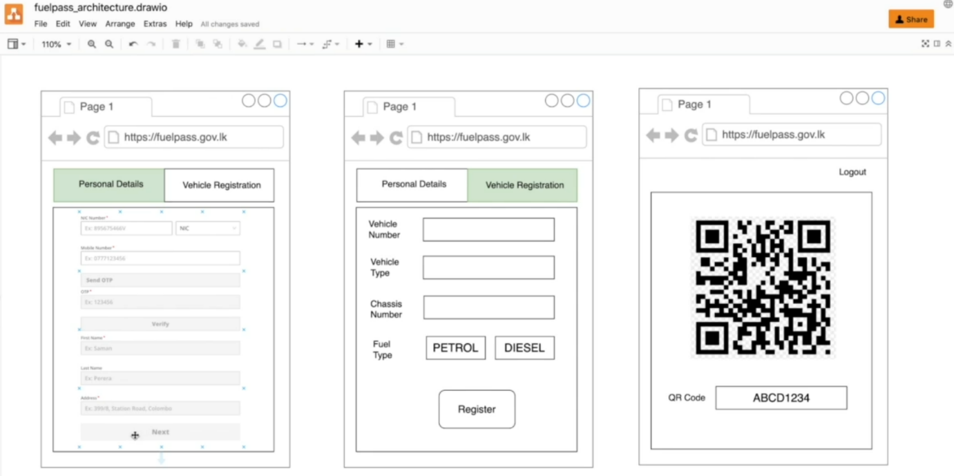

* So, then he can enter his first name, last name, address and click next. Now we need to store this information in a user table.
* So, what happened when you click next here?
* We will call upon another API End Point, and that will also happen through cloud front. So, let us imagine this path is /user-register and we have this API gateway origin attached to this path. So, API Gateway is a managed API and we can associate request authorization at API Gateway with Amazon Incognito.
* So, by this time, the user is created in the user pool.
* So, API Gateway can verify when a request is received by API Gateway whether this user is already available in Amazon Incognito. only API gateway will allow to call the user register lambda function.
* Now let us imagine, the OTP successfully sent and verified and the user is already in the user pool.
* So, API Gateway can call the **user register lambda** function and will be passing the user information such as first name, last name, and his address.
* So, we can directly save that information in a user table.
* So, the **user register Lambda** will directly store that information in a Dynamo DB table.
* So, after that, a success will be returned and then he will move over to the vehicle registration page.